Meaghan Barrett
Bio4600

Genome Assembly Quality Assessment, Annotation, and Pangenome Analysis of Salmonella enterica Serovars

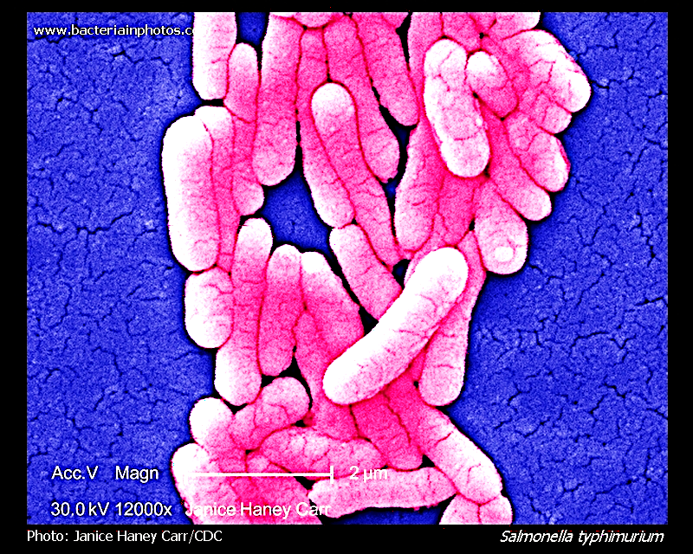

Abstract
Genome assemblies with high quality are necessary for accurately comparing genomics and interpreting bacteria diversity. This study started with 13 Salmonella enterica genome assemblies representing the diverse serovars evaluated using reproducible bioinformatics workflow to integrate quality assembly assessment, genome annotation, and pangenome analysis.
The genome completeness scores were assessed using BUSCO v6 with the bacteria_odb10 dataset, using a quality threshold of ≥90% BUSCO completeness scores. This resulted in the removal of 4 lower quality assemblies. The remaining nine high-quality genomes retained: Salmonella enterica serovar Typhi str. Ty2 (GCF_000007545.1), Schwarzengrund CVM19633 (GCF_000020745.1), Agona SL483 (GCF_000020885.1), Dublin CT_02021853 (GCF_000020925.1), Typhimurium 14028S (GCF_000022165.1), Saintpaul SARA23 (GCF_000170215.1), Newport SL317 (GCF_000171415.1), Hadar RI_05P066 (GCF_000171515.1), and Virchow SL491 (GCF_000171535.2).
Prior to filtering out the lower quality genomes, the BUSCO completeness scores ranged from 67.7% to 100% across all genomes. High-quality assemblies displayed low contig counts and high N50 values, while fragmented assemblies showed reduced completeness. Pangenome analysis identified 6,598 gene clusters, including 3,686 core genes and 2,912 accessory genes. Accessory genes were enriched for mobile genetic elements and hypothetical proteins, indicating genomic diversification among serovars.

1. Introduction
Salmonella enterica is considered a genetically diverse bacterial species composed of multiple serovars associated with human and animal disease (Liebana et al. 2002; Trees et al. 2024). Insights are gained through comparative genomics about evolutionary relationships, virulence factors, and adaptation mechanisms. However, differences in the quality of genome assemblies can be very biased in downstream analyses.
To address the issue of bias, genome assemblies must be evaluated using standardized metrics before comparative analysis. BUSCO provides a widely used measure of genome completeness based on conserved single-copy orthologs (Tegenfeldt et al. 2025). After quality filtering, genome annotation and pangenome analysis identified conserved and variable genetic elements.
The objective of this study was to:
- Evaluate genome assembly quality
- Filter genomes based on BUSCO completeness scores
- Annotate high-quality genomes
- Construct and analyze the pangenome of selected Salmonella enterica serovars

2. Methods

2.1 Genome Dataset
Thirteen Salmonella enterica genomes obtained from NCBI RefSeq. include:
- Typhi str. Ty2 (GCF_000007545.1)
- Schwarzengrund str. CVM19633 (GCF_000020745.1)
- Agona str. SL483 (GCF_000020885.1)
- Dublin str. CT_02021853 (GCF_000020925.1)
- Typhimurium str. 14028S (GCF_000022165.1)
- Saintpaul str. SARA23 (GCF_000170215.1)
- 4,[5],12:i:- str. CVM23701 (GCF_000170255.1)
- Javiana str. GA_MM04042433 (GCF_000171255.1)
- Kentucky str. CDC 191 (GCF_000171275.1)
- Heidelberg str. SL486 (GCF_000171315.1)
- Newport str. SL317 (GCF_000171415.1)
- Hadar str. RI_05P066 (GCF_000171515.1)
- Virchow str. SL491 (GCF_000171535.2)

To minimize any potential bias during quality assessment, genome assemblies were initially processed and evaluated using only accession identifiers. Serovar simplified names were added after quality filtering and metric calculation. This ensured that assembly evaluation was based solely on quantitative metrics rather than prior biased expectations.

2.2 Genome Assembly Quality Assessment
Genome completeness was evaluated using BUSCO v6 with the bacteria_odb10 lineage dataset. Metrics included complete (C), single-copy (S), duplicated (D), fragmented (F), and missing (M) genes (Tegenfeldt et al. 2025).

2.3 Genome Filtering
The BUSCO completeness threshold contains genomes scoring ≥90%. Genomes below this threshold were excluded to ensure comparative analysis is of high-quality. This resulted in keeping 9 high-quality genomes. The four shaded genomes below are the ones removed.
Name | Accession | C | S | D | F | M | N
Typhi str. Ty2 | GCF_000007545.1 | 100.0 | 100.0 | 0.0 | 0.0 | 0.0 | 124
Schwarzengrund str. CVM19633 | GCF_000020745.1 | 98.4 | 98.4 | 0.0 | 0.0 | 1.6 | 124
Agona str. SL483 | GCF_000020885.1 | 99.2 | 99.2 | 0.0 | 0.0 | 0.8 | 124
Dublin str. CT_02021853 | GCF_000020925.1 | 98.4 | 98.4 | 0.0 | 0.0 | 1.6 | 124
Typhimurium str. 14028S | GCF_000022165.1 | 98.4 | 98.4 | 0.0 | 0.0 | 1.6 | 124
Saintpaul str. SARA23 | GCF_000170215.1 | 98.4 | 98.4 | 0.0 | 0.0 | 1.6 | 124
4,[5],12:i:- str. CVM23701 | GCF_000170255.1 | 69.4 | 69.4 | 0.0 | 5.6 | 25.0 | 124
Javiana str. GA_MM04042433 | GCF_000171255.1 | 80.6 | 80.6 | 0.0 | 1.6 | 17.7 | 124
Kentucky str. CDC 191 | GCF_000171275.1 | 67.7 | 67.7 | 0.0 | 7.3 | 25.0 | 124
Heidelberg str. SL486 | GCF_000171315.1 | 67.7 | 67.7 | 0.0 | 5.6 | 26.6 | 124
Newport str. SL317 | GCF_000171415.1 | 98.4 | 98.4 | 0.0 | 1.6 | 0.0 | 124
Hadar str. RI_05P066 | GCF_000171515.1 | 93.5 | 93.5 | 0.0 | 0.8 | 5.6 | 124
Virchow str. SL491 | GCF_000171535.2 | 100.0 | 100.0 | 0.0 | 0.0 | 0.0 | 124

2.4 Assembly Contiguity Metrics
Assembly statistics were computed from FASTA files and summarized in a TSV file, including:
- Number of contigs
- Total genome length
- N50 values
This is shown by the visual chart below (this contains all thirteen genomes, prior to expelling the low-quality):

Name | Accession | Contigs | Total_Length | N50
Typhi str. Ty2 | GCF_000007545.1 | 1 | 4791961 | 4791961
Schwarzengrund str. CVM19633 | GCF_000020745.1 | 3 | 4823887 | 4709075
Agona str. SL483 | GCF_000020885.1 | 2 | 4836638 | 4798660
Dublin str. CT_02021853 | GCF_000020925.1 | 2 | 4917459 | 4842908
Typhimurium str. 14028S | GCF_000022165.1 | 2 | 4964097 | 4870265
Saintpaul str. SARA23 | GCF_000170215.1 | 2 | 4726474 | 4719855
4,[5],12:i:- str. CVM23701 | GCF_000170255.1 | 113 | 4895918 | 103713
Javiana str. GA_MM04042433 | GCF_000171255.1 | 19 | 4546142 | 471765
Kentucky str. CDC 191 | GCF_000171275.1 | 53 | 4696566 | 233156
Heidelberg str. SL486 | GCF_000171315.1 | 48 | 4728232 | 308442
Newport str. SL317 | GCF_000171415.1 | 63 | 4948011 | 484233
Hadar str. RI_05P066 | GCF_000171515.1 | 50 | 4793325 | 370713
Virchow str. SL491 | GCF_000171535.2 | 5 | 4876885 | 3027433

2.5 Genome Annotation
Filtered genomes were annotated using Bakta with the assistance of light database. Outputs included gene predictions, functional annotations, and genome feature summaries (Schwengers et al., 2021). These files included: .embl, .faa, .ffn, .gbff, .gff3, .tsv, .json, .log, .png, .svg, and .txt files for each genome.
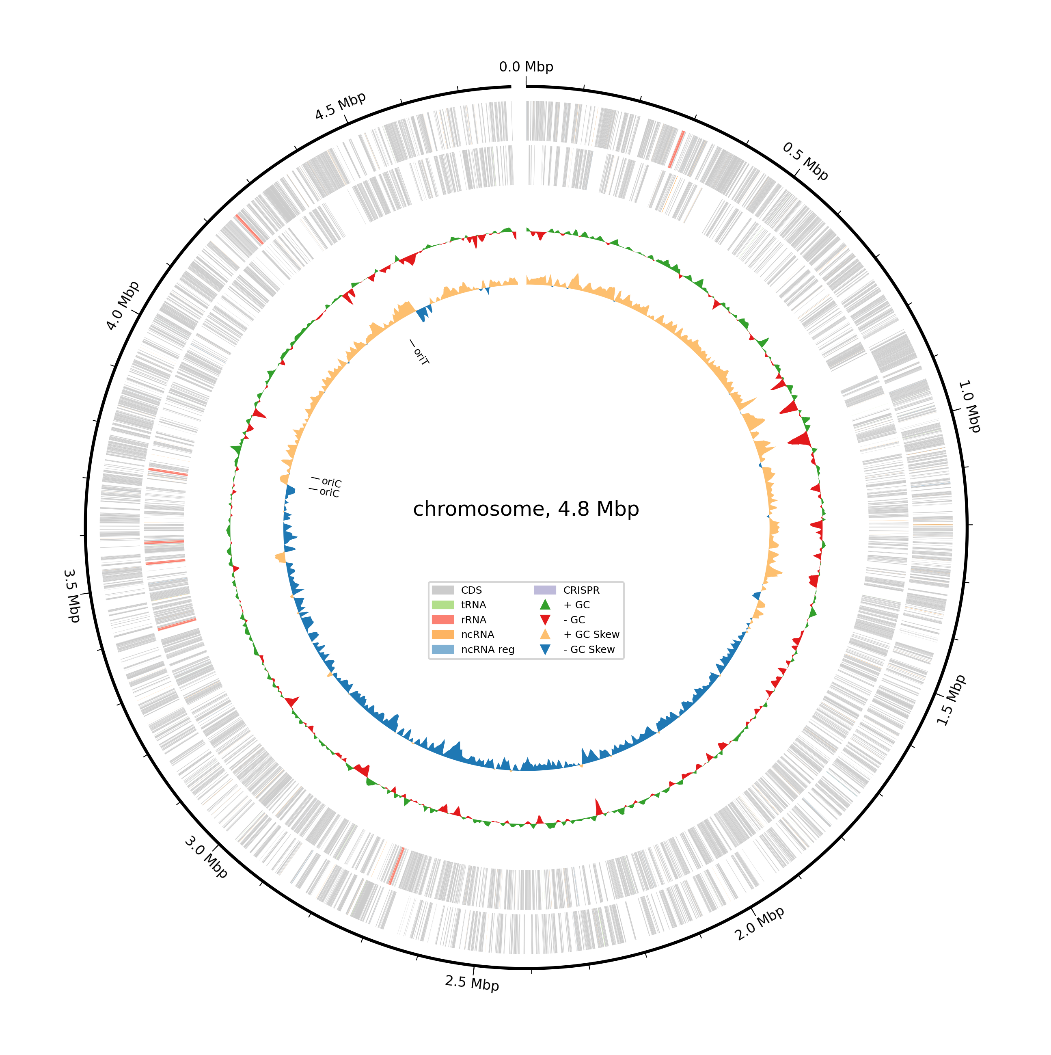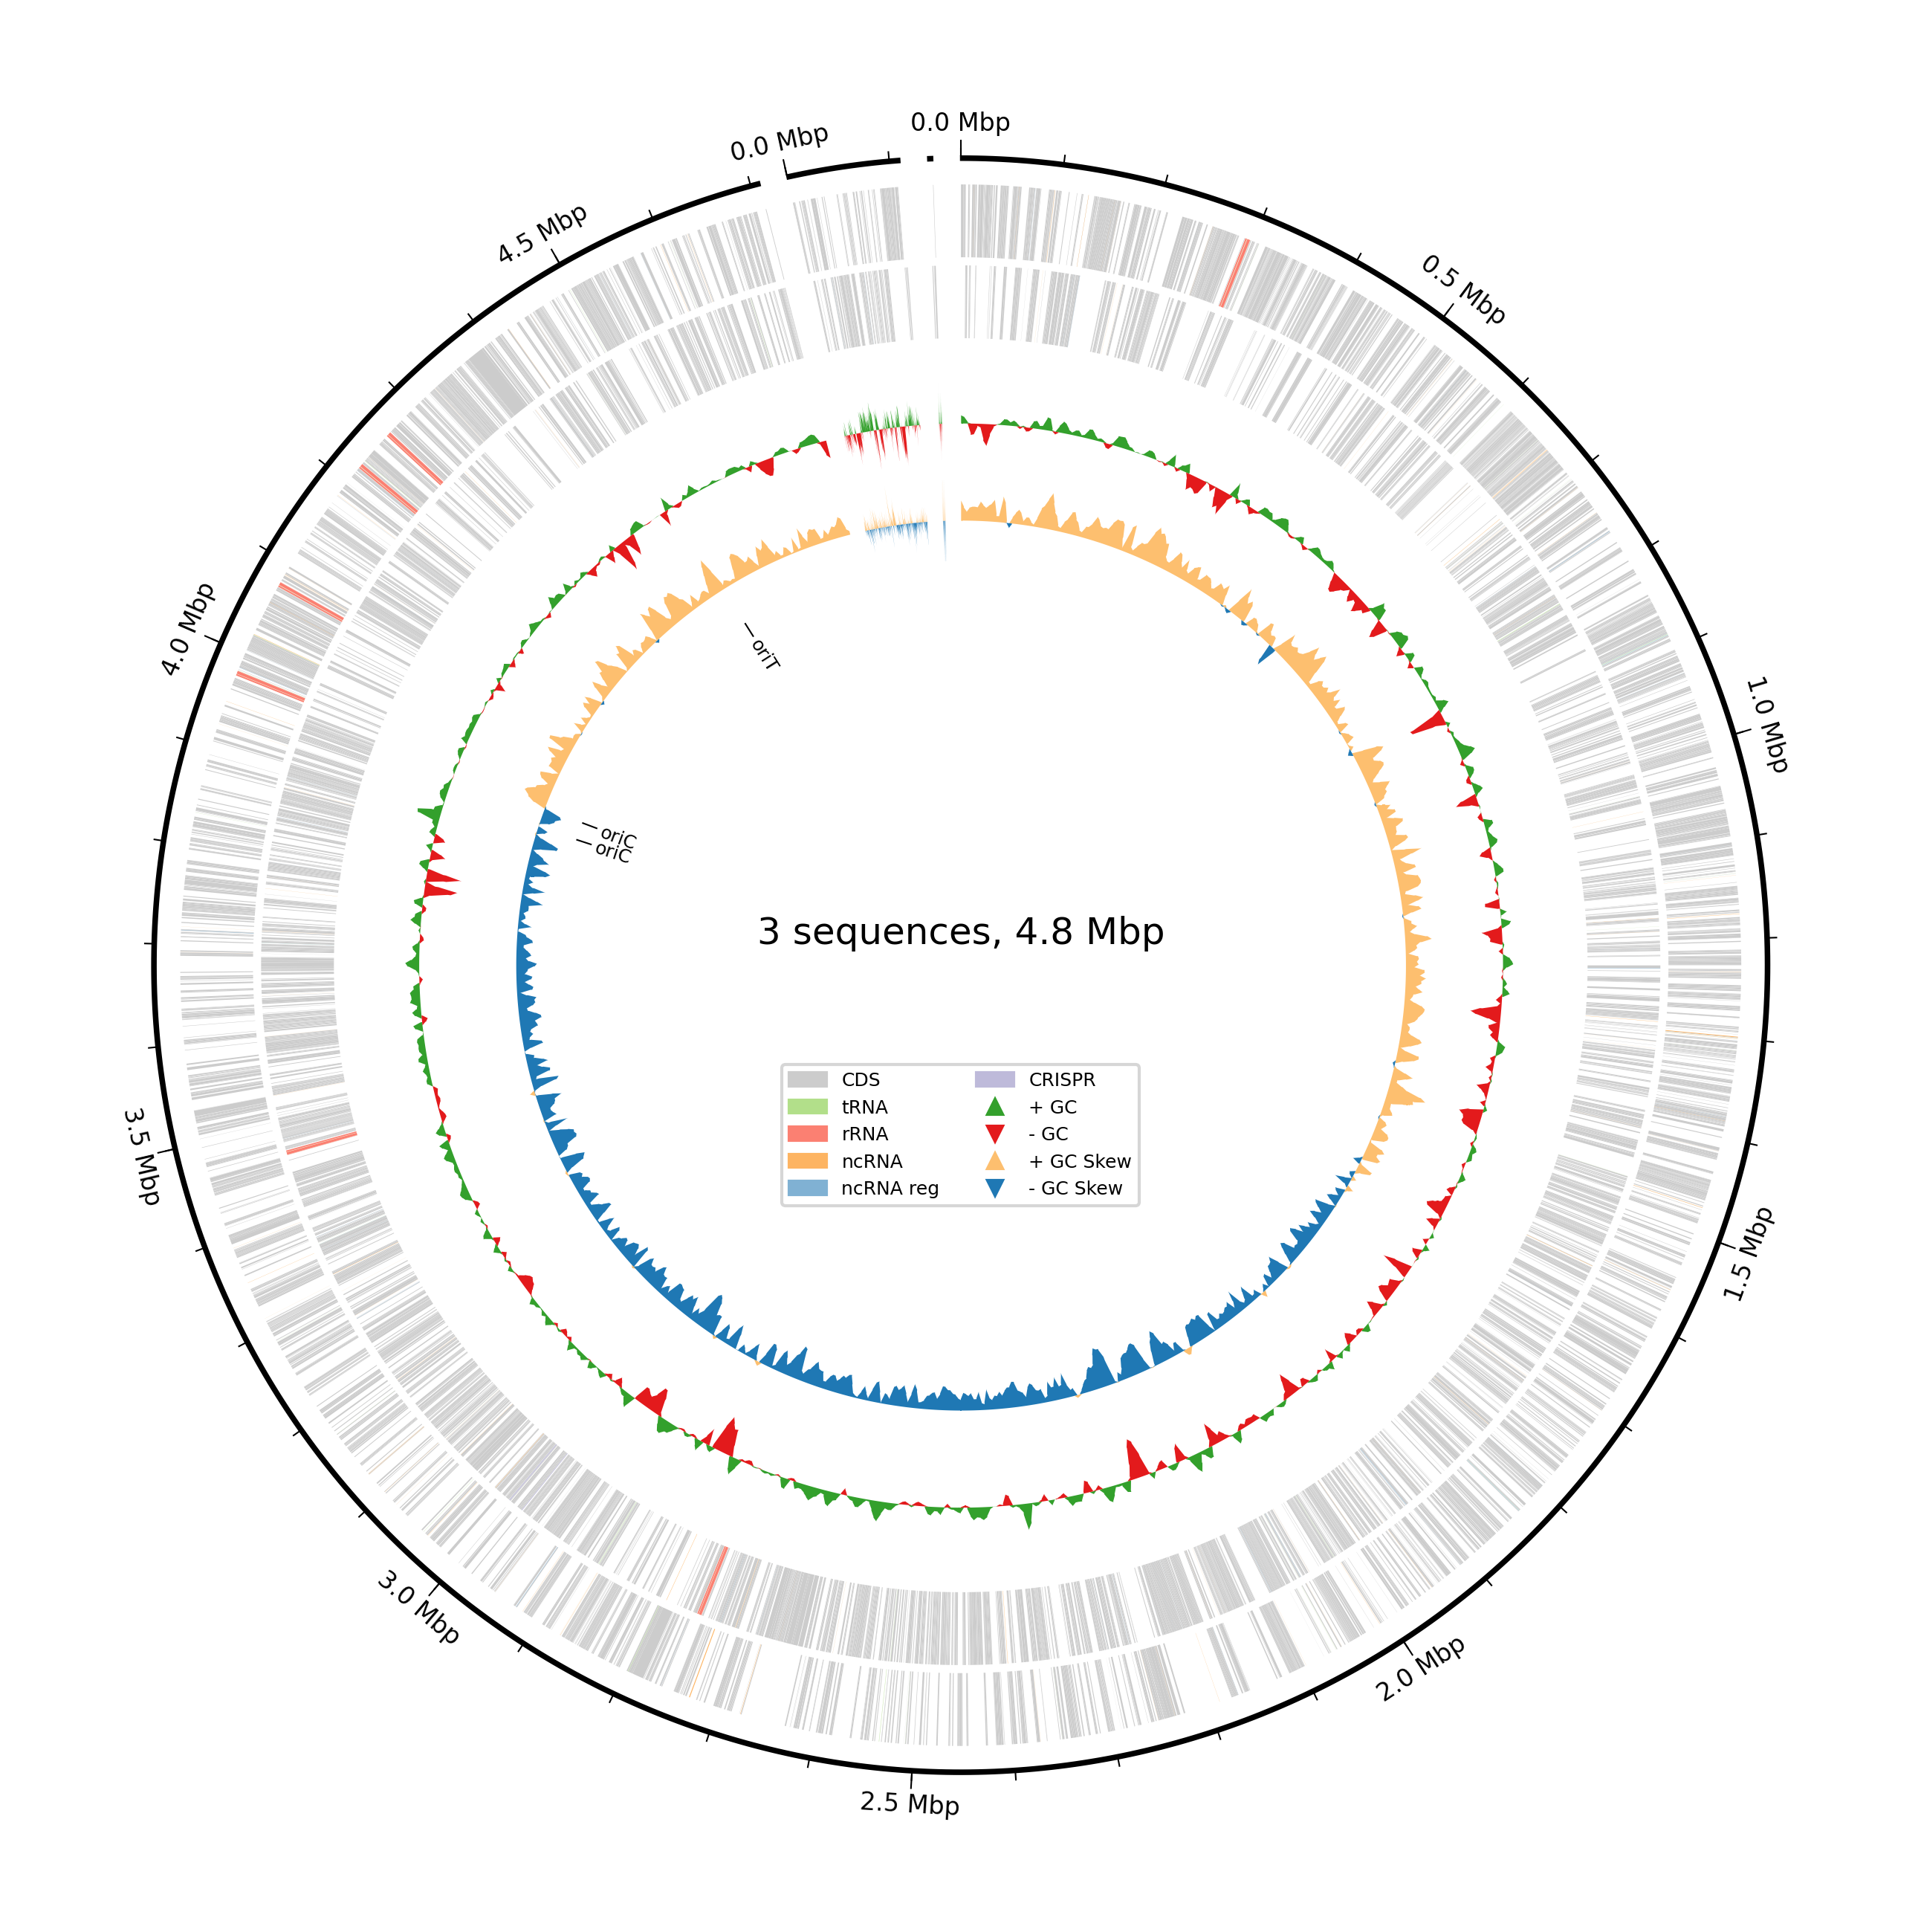
Typhi str. Ty2 (GCF_000007545.1) Schwarzengrund str. CVM19633 (GCF_000020745.1)

The graphics above show two examples of the Bakta generated circular genome map output file.

2.6 Pangenome Analysis
Panaroo was used in strict mode with MAFFT alignment (Tokin-Hill et al., 2020). Core genes were defined as present in ≥99% of genomes, while accessory genes were variably present.

Core genes | (99% <= strains <= 100%)
Soft core genes | (95% <= strains < 99%)
Shell genes | (15% <= strains < 95%)
Cloud genes | (0% <= strains < 15%)
Total genes | (0% <= strains <= 100%)

3. Results

3.1 Genome Quality Filtering
The BUSCO analysis began with 13 genomes with completeness values ranging from 67.7% to 100%. Afterwards, the four genomes below the 90% completeness threshold were excluded. Nine high-quality genomes were kept for further downstream analysis.

Name | Accession | Contigs | Total_Length | N50 | C | S | D | F | M | N
Typhi str. Ty2 | GCF_000007545.1 | 1 | 4791961 | 4791961 | 100.0 | 100.0 | 0.0 | 0.0 | 0.0 | 124
Schwarzengrund str. CVM19633 | GCF_000020745.1 | 3 | 4823887 | 4709075 | 98.4 | 98.4 | 0.0 | 0.0 | 1.6 | 124
Agona str. SL483 | GCF_000020885.1 | 2 | 4836638 | 4798660 | 99.2 | 99.2 | 0.0 | 0.0 | 0.8 | 124
Dublin str. CT_02021853 | GCF_000020925.1 | 2 | 4917459 | 4842908 | 98.4 | 98.4 | 0.0 | 0.0 | 1.6 | 124
Typhimurium str. 14028S | GCF_000022165.1 | 2 | 4964097 | 4870265 | 98.4 | 98.4 | 0.0 | 0.0 | 1.6 | 124
Saintpaul str. SARA23 | GCF_000170215.1 | 2 | 4726474 | 4719855 | 98.4 | 98.4 | 0.0 | 0.0 | 1.6 | 124
Newport str. SL317 | GCF_000171415.1 | 63 | 4948011 | 484233 | 98.4 | 98.4 | 0.0 | 1.6 | 0.0 | 124
Hadar str. RI_05P066 | GCF_000171515.1 | 50 | 4793325 | 370713 | 93.5 | 93.5 | 0.0 | 0.8 | 5.6 | 124
Virchow str. SL491 | GCF_000171535.2 | 5 | 4876885 | 3027433 | 100.0 | 100.0 | 0.0 | 0.0 | 0.0 | 124

This chart includes 9 genome BUSCO completeness scores along with contigs, total length, and N50.

3.2 Assembly Contiguity
Genomes of high quality have a strong contiguity, with 1–5 contigs and high N50 values (~4.7–4.9 Mb), this includes:
- Typhi Ty2 (GCF_000007545.1)
- Schwarzengrund (GCF_000020745.1)
- Agona (GCF_000020885.1)
- Dublin (GCF_000020925.1)
- Typhimurium (GCF_000022165.1)
- Saintpaul (GCF_000170215.1)
- Virchow (GCF_000171535.2)*
* Virchow SL491 (GCF_000171535.2) has five contigs and a lower N50 (around 3.0 Mb) compared to almost complete assemblies, it maintains a 100% BUSCO completeness value without fragmented genes. This indicates that the gene content remains fully intact and an overall high-quality genome compared to lower-quality assemblies, despite some assembly level structural fragmentation.
In contrast, fragmented genomes display noticeably higher contig counts (ranging from 19–113 contigs (this contig count was prior to the removal of low-quality genome but is still applicable)) and reduced N50 values (~100 kb–500 kb), indicating incomplete or highly fragmented assemblies. These included Newport SL317 (63 contigs), Hadar RI_05P066 (50 contigs), and several additional low-contiguity assemblies, demonstrating reduced quality assembly and structural fragmentation.
After removal of low-quality genomes, there are still some fragmented genomes showing up to 50-63 contigs and reduced N50 values (~100–400 kb), indicating lower assembly quality. In future studies, it may be best to remove these two as well.

3.3 Genome Annotation
Annotated genomes ranged from 4.73–4.96 Mb in size with consistent GC content (~52%) and coding density (~88%). Gene counts ranged from 4,336 to 4,711 CDS per genome. Hypothetical proteins accounted for 4.45%–10.52% of annotations.

Name | Genome | Length | GC | CodingDensity | CDS | Hypothe-ticals | PercentHypoth-etical | tRNA | rRNA | CRISPR
Typhi str. Ty2 | GCF_000007545.1 | 4791961 | 52.1 | 88.4 | 4618 | 486 | 10.52 | 80 | 22 | 1
Schwarzengrund str. CVM19633 | GCF_000020745.1 | 4823887 | 52.2 | 88.7 | 4533 | 263 | 5.80 | 86 | 22 | 2
Agona str. SL483 | GCF_000020885.1 | 4836638 | 52.0 | 88.7 | 4496 | 270 | 6.01 | 86 | 22 | 2
Dublin str. CT_02021853 | GCF_000020925.1 | 4917459 | 52.1 | 88.6 | 4669 | 343 | 7.35 | 86 | 22 | 0
Typhimurium str. 14028S | GCF_000022165.1 | 4964097 | 52.2 | 88.8 | 4639 | 256 | 5.52 | 88 | 22 | 2
Saintpaul str. SARA23 | GCF_000170215.1 | 4726474 | 52.3 | 88.9 | 4336 | 193 | 4.45 | 80 | 22 | 2
Newport str. SL317 | GCF_000171415.1 | 4948011 | 52.1 | 88.8 | 4711 | 334 | 7.09 | 65 | 2 | 6
Hadar str. RI_05P066 | GCF_000171515.1 | 4793325 | 52.3 | 88.9 | 4469 | 270 | 6.04 | 86 | 33 | 2
Virchow str. SL491 | GCF_000171535.2 | 4876885 | 52.1 | 88.7 | 4579 | 269 | 5.87 | 86 | 22 | 2

3.4 Pangenome Structure
A total of 6,598 gene clusters were identified:
- Core genes: 3,686 (55.9%)
- Shell genes: 1,360 (20.6%)
- Cloud genes: 1,552 (23.5%)
The accessory (Shell and Cloud genes) genome represented ~44% of total gene content.
Core genes | (99% <= strains <= 100%) | 3686
Soft core genes | (95% <= strains < 99%) | 0
Shell genes | (15% <= strains < 95%) | 1360
Cloud genes | (0% <= strains < 15%) | 1552
Total genes | (0% <= strains <= 100%) | 6598

3.5 Functional Analysis
Accessory (Shell and Cloud) genes enhance mobile genetic elements including transposases, integrases, and phage-associated genes for adaptation (Tonkin-Hill et al., 2020; Jackson et al., 2011). Core genes are mainly associated with essential cellular functions along with membrane-associated processes (Matthews et al., 2024).

4. Discussion
The quality of genome assemblies is measurable but have a subtitle impact on downstream comparative analysis. While BUSCO completeness scores identify incomplete genomes, it did not fully capture assembly contiguity. Several retained genomes (Newport SL317 and Hadar RI_05P066) exhibited high completeness (>93%) but remain highly fragmented (50–63 contigs, low N50). This distinction highlights something important: completeness reflects gene content, whereas contiguity exposes structural continuity. Both metrics are necessary for genome evaluation.
Highly contiguous genomes such as Typhi Ty2 and Agona SL483 approach complete chromosomal assemblies, with single or almost single contigs and N50 values approximating the total genome length. Providing assemblies with a reliable context for structural analysis. In contrast, Virchow SL491, although complete, shows moderate structural fragmentation, suggesting unresolved repeat regions or even assembly limitations.
The genome annotation results further supported the overall dataset consistency, with genome sizes (~4.7–5.0 Mb), GC content (~52%), and coding density (~88%) remaining highly conserved across serovars. However, there are variations in CDS counts and the proportion of hypothetical proteins (4.45%–10.52%) suggests functional diversification among the strains. These differences may reflect variation, including gene gain/loss events, environmental adaptation, or host associated conditions occurred.
Some notable annotation of structural features observed, included for example, Newport SL317 exhibited an unusually low rRNA gene count and elevated CRISPR content compared to other genomes. These deviations could indicate variations, but they may also reflect assembly fragmentation or annotation artifacts. This reinforces the importance to interpret the assembly quality for functional annotation context.
The pangenome analysis revealed a considerable amount of accessory genome (~44% of total genes), consistent with the known genomic plasticity of Salmonella enterica (Tonkin-Hill et al., 2020). The enhancement of mobile genetic elements, including transposases, integrases, and phage-associated genes, supports the role of horizontal gene transfer in shaping genome diversity (Tonkin-Hill et al., 2020; Jackson et al., 2011). Whereas in contrast, Core genes were mainly associated with essential cellular and membrane-related functions, reflecting conserved biological processes required for survival (Matthews et al., 2024).
Also, to reduce potential bias during analysis, genome assemblies were initially evaluated using only the accession identifiers (GCF_) rather than serovar names and were incorporated only after quality filtering and metric calculation. This was to ensure that genome selection and evaluation were based solely on quantitative assembly metrics rather than prior expectations about specific serovars.
Overall, these findings demonstrate that combining BUSCO completeness with contiguity metrics and using Bakta to annotate outputs to provide a more comprehensive framework for genome quality assessment. Reliance on a single metric may overlook potentially important limitations in the assembly structure or annotation accuracy.

5. Conclusion
This study produced a reproducible bioinformatics workflow that can be seen on < https://github.com/BARRETTMEAG/Bioinformatics-Capstone-MeaghanBarrett.git > for evaluating the quality of genome assemblies, performing genome annotation, and conducting pangenome analysis of Salmonella enterica serovars.
The genomes were filtered according to BUSCO completeness, thus effectively removed low-quality genomes; however, upon further contiguity metrics evaluation revealed that some of the retained genomes remain structurally fragmented. This highlights the importance of having multiple quality metrics, including contig count and N50, ensuring accurate genome assessment.
The results for genome annotation demonstrates a strong upkeep in genome size, GC content, and coding density across serovars, together with adequate variation in gene content and hypothetical protein representation. Pangenome analysis reveals a conserved core genome and a diversely large accessory genome enriched in mobile genetic elements, supporting ongoing genomic adaptation (Tonkin-Hill et al., 2020; Jackson et al., 2011).
These results altogether, emphasize that comparative genomes of high-quality requires careful filtering, multi-metric evaluation, and consideration of both technical and biological sources of variation. This workflow provides a vigorous and reproducible framework for future bacterial genome analysis and comparative studies.

References

Carr, Janice Haney Salmonella typhimurium photo (2015), https://www.microbiologyinpictures.com/bacteria-photos/salmonella-photos/salmonella-typhimurium-sem.html

Jackson, Robert W et al. “The influence of the accessory genome on bacterial pathogen evolution.” Mobile genetic elements vol. 1,1 (2011): 55-65. doi:10.4161/mge.1.1.16432

Liebana E, Garcia-Migura L, Clouting C, Cassar CA, Clifton-Hadley FA, Lindsay EA, Threlfall EJ, Chappell SA, Davies RH. Investigation of the genetic diversity among isolates of Salmonella enterica serovar Dublin from animals and humans from England, Wales and Ireland. J Appl Microbiol. 2002;93(5):732-44. doi: 10.1046/j.1365-2672.2002.01737.x. PMID: 12392517.

Matthews CA, Watson-Haigh NS, Burton RA, Sheppard AE. A gentle introduction to pangenomics. Brief Bioinform. 2024 Sep 23;25(6):bbae588. doi: 10.1093/bib/bbae588. PMID: 39552065; PMCID: PMC11570541.

Schwengers O., Jelonek L., Dieckmann M. A., Beyvers S., Blom J., Goesmann A. (2021). Bakta: rapid and standardized annotation of bacterial genomes via alignment-free sequence identification. Microbial Genomics, 7(11). https://doi.org/10.1099/mgen.0.000685

Tegenfeldt F., Kuznetsov D., Manni M., Berkeley M., Zdobnov E.M., Kriventseva E.V. OrthoDB and BUSCO update: annotation of orthologs with wider sampling of genomes. Nucleic Acids Research, Volume 53, Issue D1, 6 January 2025, Pages D516–D522, https://doi.org/10.1093/nar/gkae987

Tonkin-Hill G, MacAlasdair N, Ruis C, Weimann A, Horesh G, Lees JA, Gladstone RA, Lo S, Beaudoin C, Floto RA, Frost SDW, Corander J, Bentley SD, Parkhill J. 2020. Producing polished prokaryotic pangenomes with the Panaroo pipeline. Genome Biol 21:180.

Trees, E., Carleton, H. A., Folster, J. P., Gieraltowski, L., Hise, K., Leeper, M., Nguyen, T.-A., Poates, A., Sabol, A., Tagg, K. A., Tolar, B., Vasser, M., Webb, H. E., Wise, M., & Lindsey, R. L. (2024). Genetic Diversity in Salmonella enterica in Outbreaks of Foodborne and Zoonotic Origin in the USA in 2006–2017. Microorganisms, 12(8), 1563. https://doi.org/10.3390/microorganisms12081563

